Lab: DOM XSS in jQuery anchor href attribute sink using location.search source
Prepared By: Nihar Mane

INDEX
Report Metadata……………………………………………………………………………………………..2
Executive Summary…………………………………………………………………………………………2
Scope…………………………………………………………………………………………………………2
Methodology………………………………………………………………………………………………….2
Step-by-Step Execution……………………………………………………………………………………..2
Impact Assessment………………………………………………………………………………………….4
Remediation………………………………………………………………………………………………….5
Conclusion……………………………………………………………………………………………………5
References……………………………………………………………………………………………………5

Report Metadata

Lab: DOM XSS in jQuery anchor href attribute sink using location.search source — PortSwigger Web Security Academy (Apprentice). Target: Submit feedback page (returnPath parameter). Tools: browser address bar, DevTools. Tester: Nihar Mane. Date: August 27, 2026. Status: Solved — alert(document.cookie) executed, lab banner reads “Solved” (Figure 4).

Executive Summary

This lab demonstrates a DOM-based XSS vulnerability where jQuery sets the href attribute of the page’s back link directly from the returnPath value in location.search, without validating it. Because href accepts the javascript: pseudo-protocol, setting returnPath to javascript:alert(document.cookie) causes the script to execute when the link is clicked.

Scope

In scope: the returnPath parameter on the Submit feedback page of the assigned PortSwigger lab instance.
Out of scope: all other endpoints and any production system.

Methodology

Modify the returnPath parameter and use DevTools to confirm it lands unescaped in an anchor’s href attribute, then replace it with a javascript: URI and trigger the link.

Step-by-Step Execution

Step 1: On the Submit feedback page, change the query parameter returnPath to / followed by a random alphanumeric string.
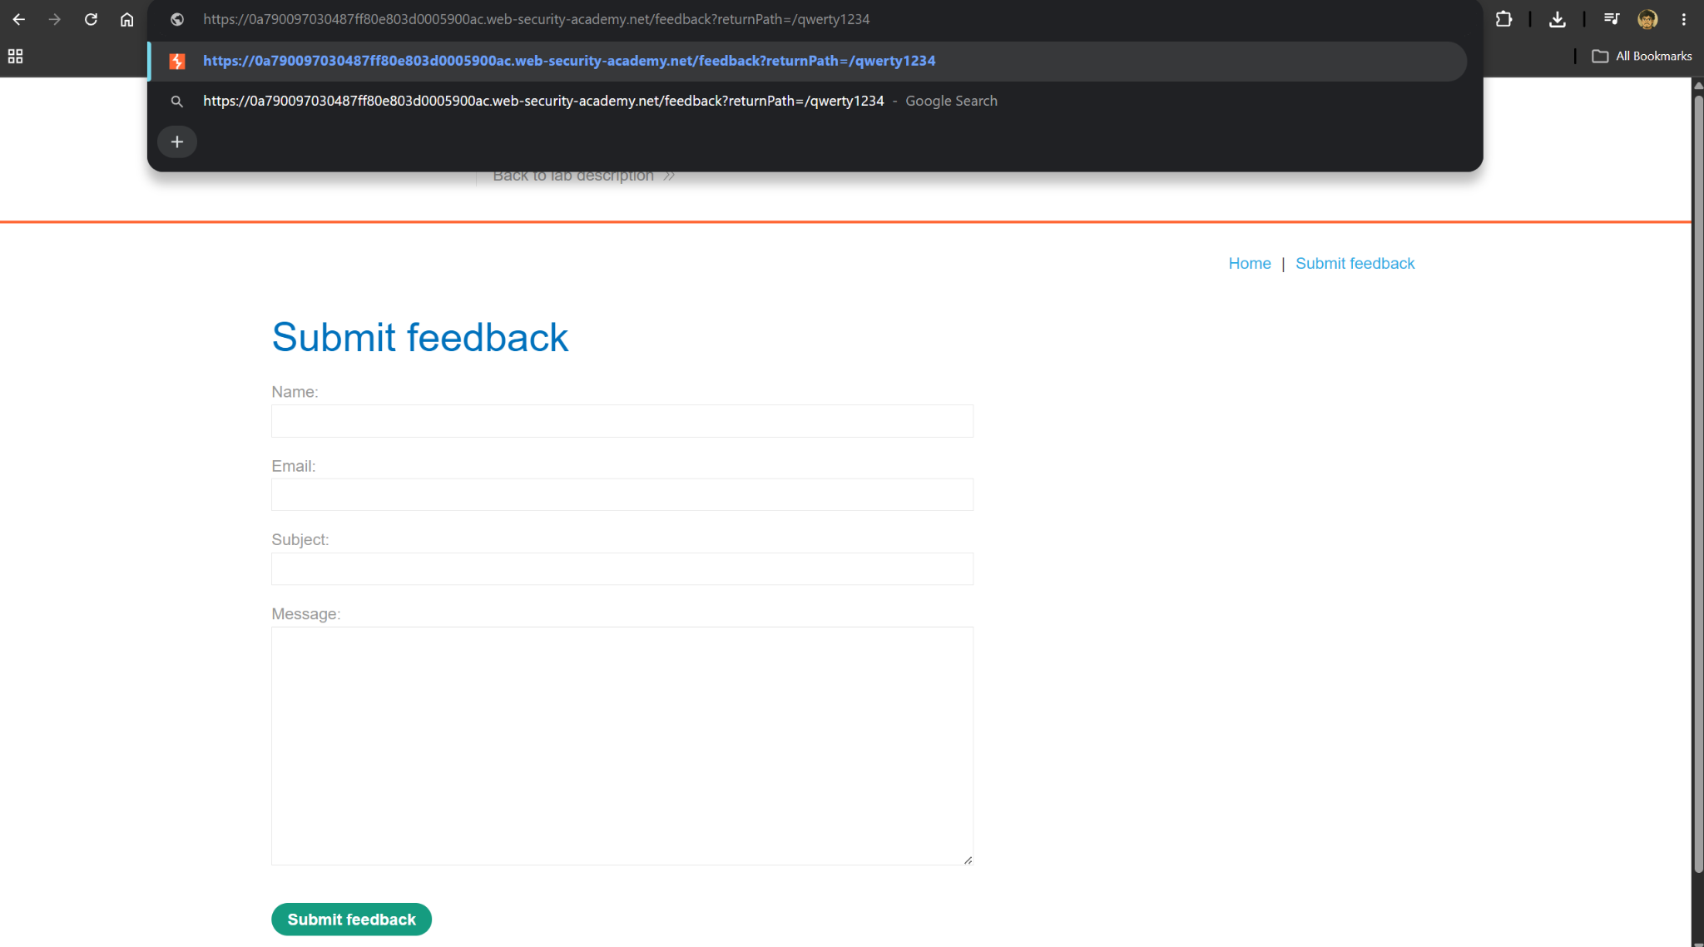

Step 2: Right-click and inspect the element, and observe that your random string has been placed inside an a href attribute.

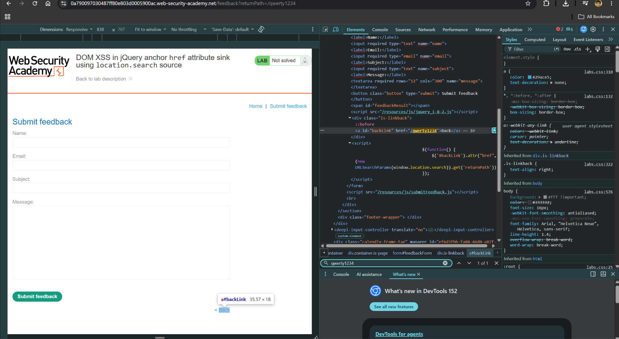

Step 3: Change returnPath to: javascript:alert(document.cookie) Hit enter and click "back".

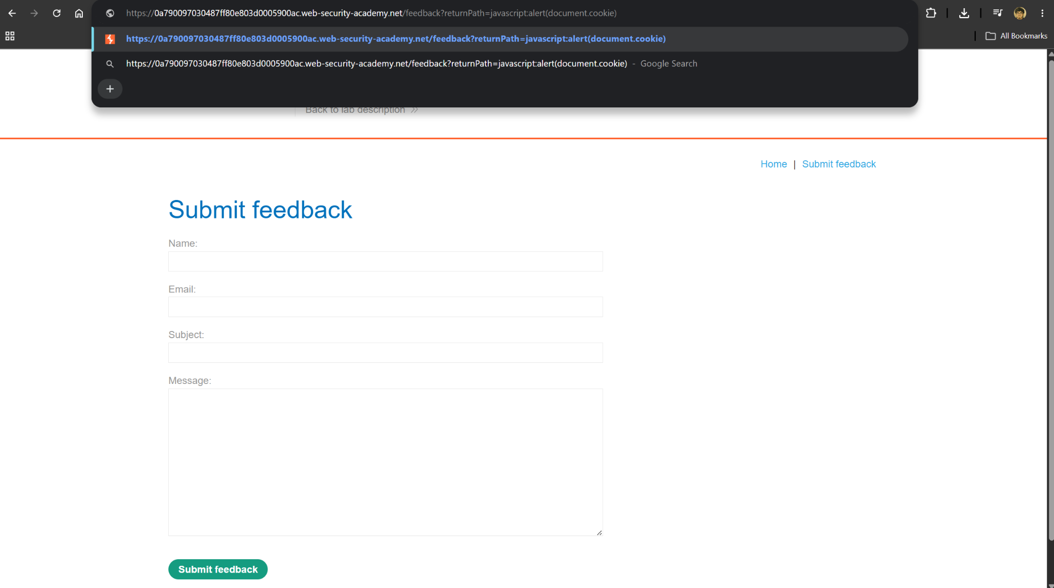

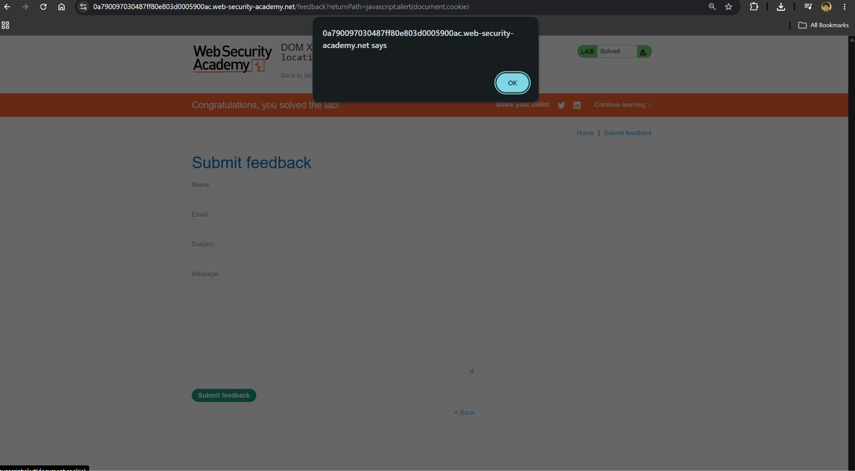

Impact Assessment

• Client-side, purely DOM-based: the payload never reaches the server, so it can evade server-side filters and logging.
• Full script execution: an attacker can hijack the victim’s session or read their cookies once the link is clicked.
• Easy delivery: the attack only requires getting a victim to click a crafted feedback-page link and then the resulting backlink.

Remediation

• Never assign attacker-controllable data directly to an href (or similar) attribute without validation.
• Restrict accepted values to a safe allowlist of protocols/paths (e.g. only relative paths), rejecting javascript: and other unsafe schemes.
• Apply a Content Security Policy to limit the impact of any script that does execute.

Conclusion

This lab showed that even a UI convenience feature, a dynamically generated back link, can become a full script-execution vector when its value is taken unescaped from the URL. As with the earlier DOM XSS labs, the fix is to validate and constrain attacker-controllable data before it reaches a sensitive sink like href.

References

- LAB https://portswigger.net/web-security/cross-site-scripting/dom-based/lab-jquery-href-attribute-sink

